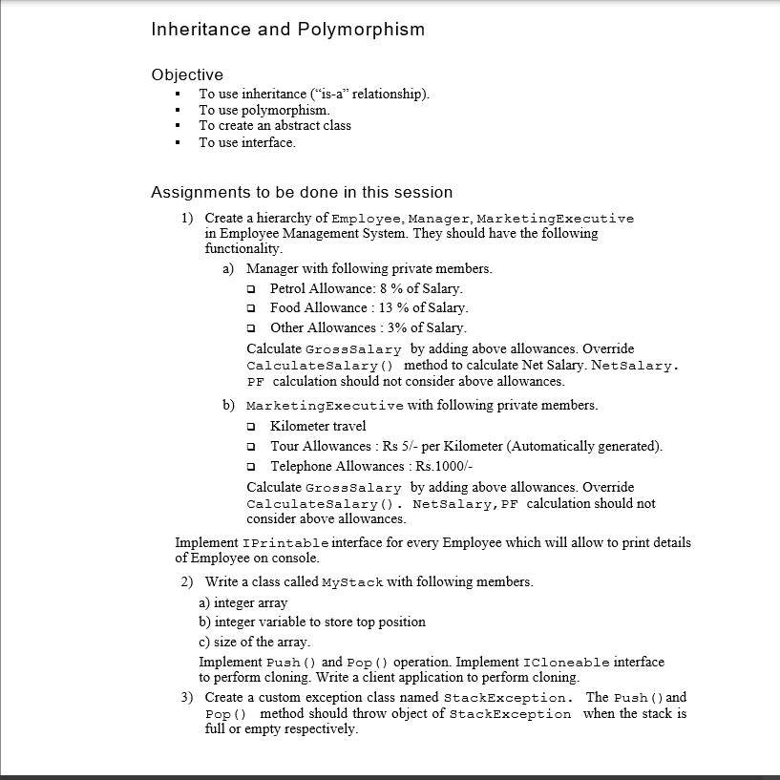

using System;

using System.Collections.Generic;

using System.Linq;

using System.Text;

using System.Threading.Tasks;

using static System.Console;

namespace EmployeeManagementSystem

{

public interface IPrintable

{

void DisplayEmployeeDetails();

}

public class Employee

{

public int emp_id;

public string emp_name;

public float Salary;

public float GrossSalary;

public void GetSalaryWithEmployeeDetails()

{

WriteLine("Enter Employee Details Like emp_id,emp_name");

emp_id = int.Parse(ReadLine());

emp_name = ReadLine();

WriteLine("Enter Salary of an Employe .");

Salary = float.Parse(ReadLine());

}

public virtual void CalculateSalary()

{

}

}

public class Manager : Employee, IPrintable

{

private float PA;

private float FA;

private float OA;

public override void CalculateSalary()

{

PA = 8 * Salary / 100;

FA = 13 * Salary / 100;

OA = 3 * Salary / 100;

GrossSalary = Salary + PA + FA + OA;

}

public void DisplayEmployeeDetails()

{

WriteLine("Manager Details...");

WriteLine("emp_id: {0}\nemp_name: {1}\nGrossSalary:{2}", emp_id, emp_name, GrossSalary);

}

}

public class MarketingExecutive : Employee, IPrintable

//inherited Employee class and interface IEmployee

{

private int Distance;

private float TourAllowances;

private float Telephone_Allowances;

public override void CalculateSalary() //override method of Employee class

{

WriteLine("Enter Distance travelled during Marketing Executive in km");

Distance = int.Parse(ReadLine());//taking distance input

TourAllowances = 5 * Distance; //5 rupees per km

Telephone_Allowances = 1000;

GrossSalary = Salary + TourAllowances + Telephone_Allowances;

}

public void DisplayEmployeeDetails() //implementation of interface method

{

WriteLine("Marketing Executive Details....");

WriteLine("emp_id: {0}\n emp_name: {1}\nGross Salary:{2}", emp_id, emp_name, GrossSalary);

}

}

internal class Program

{

static void Main(string[] args)

{

Manager mg = new Manager();

MarketingExecutive me = new MarketingExecutive();

WriteLine("Manager Input");

mg.GetSalaryWithEmployeeDetails();

mg.CalculateSalary();

mg.DisplayEmployeeDetails();

WriteLine("Marketing Executive Input");

me.GetSalaryWithEmployeeDetails();

me.CalculateSalary();

me.DisplayEmployeeDetails();

ReadLine();

}

}

}

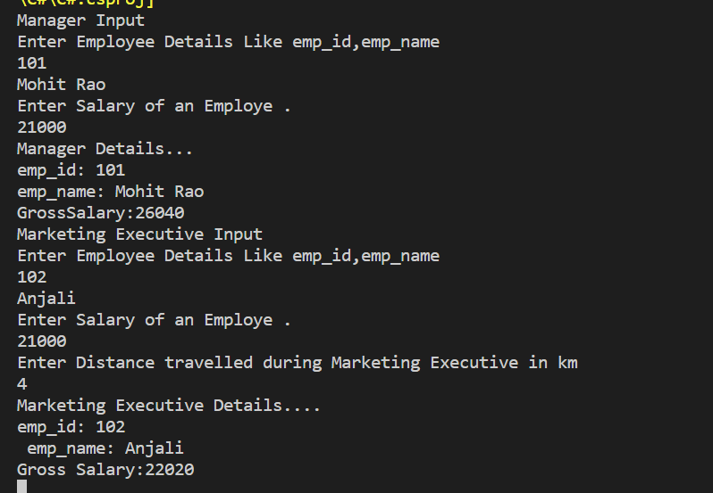

using System;

using System.Collections.Generic;

using System.Linq;

using System.Text;

using System.Threading.Tasks;

using static System.Console;

using static System.Convert;

namespace MyStackPushPop

{

public class MyStack

{

int size_of_stack;

int top_position = 0;

int[] array = new int[20];

public void GetSizeOfStack()//for getting size of stack

{

WriteLine("Enter Size of Stack");

size_of_stack = int.Parse(ReadLine());

}

public void Push()

{

if (top_position == (size_of_stack - 1))

{

WriteLine("Stack is Full");

}

else

{

for (int i = 0; i < size_of_stack; i++)

{

WriteLine("Insert element in stack");

int element = int.Parse(ReadLine());

array[++top_position] = element;

WriteLine("Item pushed Successfully!");

}

}

}

public object Pop()

{

if (top_position == -1)

{

WriteLine("Stack is Empty");

return "No elements";

}

else

{

return array[top_position--];

}

}

public void Display()

{

for (int i = top_position; i > 0; i--)

{

WriteLine("Item {0}: |{1}| ", (i), array[i]);

}

ReadLine();

}

}

internal class Program

{

static void Main(string[] args)

{

MyStack stack = new MyStack();

//stack.GetSizeOfStack();

while (true)

{

Clear();

WriteLine("Stack Menu Program");

WriteLine("1. Enter Size of Stack");

WriteLine("2. Push operation");

WriteLine("3. Pop Operation");

WriteLine("4. Display ");

WriteLine("5. Exit");

Write("Enter Your Choice");

int choice = ToInt32(ReadLine());

switch (choice)

{

case 1:

stack.GetSizeOfStack();

break;

case 2:

stack.Push();

break;

case 3:

WriteLine("Element removed: {0}", stack.Pop());

ReadLine();

break;

case 4:

stack.Display();

break;

case 5:

Environment.Exit(0);

break;

}

}

}

}

}

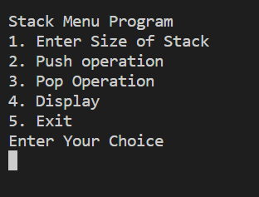

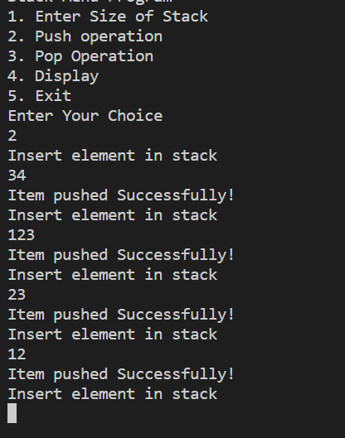

using System;

using System.Collections;

using System.Collections.Generic;

using System.Data;

using System.Diagnostics;

using System.Linq;

using System.Text;

using System.Threading.Tasks;

namespace StackExceptionPro

{

interface Istack

{

Boolean IsEmpty();

void Push(object element);

object Pop();

object Peek();

void Display();

}

class PushPop : Istack

{

public int top;

object[] item;

public int stack_size;

public PushPop(int stack_size) //parametrised constructor

{

this.stack_size = stack_size;

item = new object[stack_size];

top = -1;

}

public PushPop() //default constructor

{

stack_size = 10;

item = new object[stack_size];

top = -1;

}

public bool IsEmpty() //Method to check is stack empty or full

{

if (top == (stack_size - 1))

{

return true;

}

else

return false;

}

public void Push(object element)

{

if (top == (stack_size - 1))

{

throw new Exception("Exception Stack overflow because stack is full");

}

else

{

item[++top] = element;

Console.WriteLine("Item Pushed Successfully");

}

}

public object Pop()

{

if (IsEmpty())

{

throw new Exception("Exception underflow because stack is empty");

return null;

}

else

{

return item[top--];

}

}

public object Peek()

{

if (IsEmpty())

{

throw new Exception("Stack Underflow exception because stack is empty");

return null;

}

else

{

return item[top];

}

}

public void Display()

{

for (int i = top; i > -1; i--)

{

Console.WriteLine(item[i]);

}

}

}

internal class Program

{

static void Main(string[] args)

{

PushPop st = new PushPop();

object element;

while (true)

{

Console.Clear();

Console.WriteLine("1. IsEmpty()");

Console.WriteLine("2. Push()");

Console.WriteLine("3. Pop()");

Console.WriteLine("4. Peek()");

Console.WriteLine("5. Display()");

Console.WriteLine("6. Exit()");

Console.WriteLine("Enter Your Choice");

int choice;

choice = int.Parse(Console.ReadLine());

Console.WriteLine();

switch (choice)

{

case 1:

if (st.IsEmpty())

{

Console.WriteLine("Stack is Empty");

}

else

{

Console.WriteLine("Stack is not empty");

}

break;

case 2:

Console.WriteLine("Enter element");

element = Console.ReadLine();

try

{

st.Push(element);

}

catch (StackOverflowException e)

{

Console.WriteLine(e.Message);

}

break;

case 3:

try

{

element = st.Pop();

Console.WriteLine("Element removed is {0} ", element);

}

catch (Exception e)

{

Console.WriteLine(e.Message);

}

break;

case 4:

try

{

element = st.Peek();

Console.WriteLine("Element removed is {0} ", element);

}

catch (Exception e)

{

Console.WriteLine(e.Message);

}

break;

case 5:

st.Display();

break;

case 6:

Environment.Exit(0);

break;

default:

Console.WriteLine("Enter valid choice");

break;

}

Console.ReadLine();

}

}

